Natural versus Synthetic Repellents for Aedes aegypti: A Systematic Review and Meta-Analysis of Efficacy and Protection Duration

Background: Aedes aegypti is the primary vector of dengue, Zika, chikungunya, and yellow fever, creating a substantial public health burden in tropical and subtropical regions. Personal protective measures, particularly topical and wearable repellents, remain practical options for reducing mosquito bites. However, the comparative efficacy and protection duration of natural botanical repellents and synthetic chemical repellents against Ae. aegypti have not been comprehensively quantified.
Methods: PubMed, Scopus, Web of Science, and Embase were searched for studies published from 2004 to 2025. Eligible studies reported PP% and/or CPT for repellent formulations tested against Ae. aegypti. Random-effects meta-analysis was performed. Heterogeneity was assessed using the I² statistic and Cochran’s Q test. Risk of bias was evaluated using the Cochrane Risk of Bias 2.0 tool.
Results: Thirty studies involving 2,455 participants or experimental replicates were included. Synthetic repellents showed a pooled mean PP% of 91.5% and a mean CPT of 6.1 h. Natural repellents showed a pooled mean PP% of 67.4% and a mean CPT of 2.9 h. DEET at 20–35% demonstrated the most consistent and sustained efficacy. Among natural formulations, Angelica sinensis essential oil, Ligusticum sinense nanoemulsion, and nootkatone showed the most promising profiles.
Conclusion: Synthetic repellents, particularly DEET and picaridin, remain more effective and longer lasting than natural alternatives against Ae. aegypti. Advanced botanical formulations may still support future vector-control strategies.
Keywords: Aedes aegypti, DEET, dengue vector control, essential oils, natural repellents.

INTRODUCTION
Aedes aegypti (Linnaeus, 1762) is a highly anthropophilic mosquito species and the primary arboviral vector responsible for transmitting dengue fever, Zika virus, chikungunya, and yellow fever (1,2). The World Health Organization estimates that about 390 million people are infected with dengue each year. Globally, this puts 3.9 billion people across more than 129 countries at risk (3). Control of Ae. aegypti remains an urgent priority in tropical and subtropical regions such as Southeast Asia, Latin America, and sub-Saharan Africa.
Among the personal protective measures currently available, topically applied or wearable insect repellents represent a first line of individual defense against mosquito bites. For more than six decades, the synthetic compound N,N-diethyl-3-methylbenzamide (DEET) has been the gold-standard repellent, showing broad-spectrum efficacy and extended protection at various concentrations (10–50%) (4). Other synthetic compounds, such as icaridin (picaridin), ethyl butylacetylaminopropionate (IR3535), and transfluthrin, have been approved by regulatory agencies, including the US Environmental Protection Agency (EPA) and the European Chemicals Agency (ECHA) (5).
The growing interest among consumers and public health in environmentally sustainable and toxicologically benign alternatives has led to intensive research into botanical and plant-derived repellents. Several studies and reviews have evaluated essential oils, herbal extracts, and plant-derived compounds against Ae. aegypti, including formulations based on cinnamon, Thai herbal essential oils, nootkatone, and other botanical actives (6,7,9,10,15,16,21). Natural repellents are often perceived as safer because they are derived from plants; however, their efficacy and duration of protection are generally more variable than those of synthetic repellents.
However, a comprehensive meta-analysis has not synthesized the growing body of primary literature evaluating both categories to quantify and directly compare the percentage of protection (PP%) and complete protection time (CPT) of natural versus synthetic repellents specifically targeting Ae. aegypti. Existing systematic reviews are generally limited to a single active ingredient or a single repellent category, or do not apply rigorous meta-analytic methods (6,7). This gap limits the evidence-based recommendations that public health practitioners, policymakers, and individuals in dengue-endemic regions can make.
This gap is addressed herein through a systematic review and random-effects meta-analysis of studies assessing repellent efficacy (PP%) and protection duration (CPT, hours) against Ae. aegypti, stratified by repellent category (natural vs. synthetic), to determine which category and which specific formulations provide the highest and most long-lasting protection.

MATERIALS AND METHODS
Protocol and Registration
This systematic review and meta-analysis was conducted in accordance with the PRISMA 2020 guidelines. The protocol was not prospectively registered.

Inclusion Criteria
Studies were included if: (1) they tested topical or wearable repellent formulations (synthetic or natural) against Ae. aegypti in laboratory or field conditions; (2) they provided quantitative efficacy data as protection percentage (PP%) and/or complete protection time (CPT in hours); (3) they were published in peer-reviewed journals in the English language from 2004 to 2025; and (4) they used at least one validated exposure method (arm-in-cage, tunnel assay, cage assay, or field landing rate). Studies were excluded if they did not: (1) report PP% or CPT, (2) test Ae. aegypti only, (3) have only larvicidal or adulticidal activity without data on repellency, (4) were conference abstracts, theses, or grey literature not available in full text, or (5) had duplicate data from the same study population.

Sources of Information and Search Strategy
A systematic search was performed in PubMed/MEDLINE, Scopus, Web of Science, and Embase. The search was conducted in March 2025. Search terms were combinations of:
Aedes aegypti AND repellent AND (DEET OR Picaridin OR IR3535 OR essential oil OR botanical OR natural repellent OR plant extract OR protection percentage OR complete protection time). Additional eligible studies were identified through manual screening of the reference lists of included studies and relevant review articles.

Selection of studies
All databases were searched, and records were exported to the Rayyan systematic review software. Duplicates were removed, and titles and abstracts were reviewed independently by two reviewers. The full-text articles were then assessed for eligibility. Disagreements were resolved by consensus or by consulting a third reviewer. The PRISMA flowchart (Figure 1) illustrates the study selection process.

Extraction of data
Data extraction: Two reviewers independently extracted the following data from each included study: first author, year of publication, country of study, study design, type of repellent (natural or synthetic), active ingredient, concentration, mean PP%, mean CPT (hours), sample size (n) and relevant methodological details. Differences were resolved by consensus.

Statistical Analysis
Meta-analysis was performed using a random-effects model (DerSimonian-Laird estimator) to account for expected between-study heterogeneity. The log odds ratio (logit transformation of PP%) was used as the primary measure of effect. Pooled estimates with 95% confidence intervals (95% CI) were calculated separately for the synthetic and natural repellent groups and for the total sample. Heterogeneity was assessed using I² statistics and Cochran’s Q test; I² > 50% was considered substantial heterogeneity. Subgroup analyses were conducted by repellent category and concentration level. Sensitivity analyses were conducted by excluding each study in turn to assess its effect on the pooled estimates. Egger’s regression test and a funnel plot were used to assess for publication bias visually.

Risk of Bias Assessment
The risk of bias of included studies was assessed independently by two reviewers using the Cochrane Risk of Bias 2.0 (RoB 2.0) tool. This tool addresses five domains: bias arising from the randomization process; bias due to deviations from intended interventions; bias due to missing outcome data; bias in measurement of the outcome; and bias in selection of the reported result. Overall bias judgment for each study was classified as low, some concerns, or high. Results were depicted in a traffic-light plot (Figure 4).

RESULTS
Selection of studies
The first database search yielded 2,847 records (PubMed: 1,124; Scopus: 892; Web of Science: 631; Embase: 200). An additional 143 records were identified through manual reference screening and grey literature. Following the removal of 780 duplicates, 2,210 records were screened by title and abstract. Out of these, 2,042 were excluded, leaving 168 full-text articles assessed for eligibility. 138 were excluded after full-text review (not RCT/quasi-experimental: n=45; no PP% reported: n=38; no Ae. aegypti data: n=31; duplicate data: n=24). The meta-analysis included 30 studies that met all inclusion criteria (Figure 1. PRISMA Flowchart).
Study Selection Flow Diagram (PRISMA 2020)
Figure 1. PRISMA Flowchart for Study Selection

Table 1. Characteristics of the 30 Included Studies
Author (Year) | Country | Design | Repellent Type | Active Ingredient | Conc. (%) | Mean PP% | CPT (h) | n | Risk Bias
Maia et al. (2022) | Brazil | Quasi experimental | Synthetic | DEET | 15 | 97.5 | 6.0 | 120 | Low
Luker et al. (2023) | USA | Laboratory RCT | Natural | Essential oils (20 types) | Various | 62.3 | 2.1 | 90 | Low
Aungtikun and Soonwera (2021) | Thailand | Laboratory exp. | Natural | Cinnamomum spp. EO | 5-10 | 78.4 | 3.5 | 60 | Some concerns
Rodriguez et al. (2017) | USA | Laboratory RCT | Synthetic | DEET, Picaridin, IR3535 | 15-30 | 89.2 | 4.8 | 80 | Low
Phasomkusolsil and Soonwera (2010) | Thailand | Laboratory exp. | Natural | Medicinal plant oils | 5-15 | 55.7 | 1.8 | 50 | High
Junkum et al. (2021) | Thailand | Laboratory RCT | Natural | Ligusticum sinense nanoemulsion | 3 | 81.6 | 4.2 | 100 | Low
Costantini et al. (2004) | Burkina Faso | Field RCT | Synthetic | DEET, IR3535, KBR3023 | 20–35 | 91.4 | 7.0 | 200 | Low
Sritabutra et al. (2011) | Thailand | Laboratory exp. | Natural | Herbal essential oils | 10 | 67.8 | 2.8 | 45 | High
Clarkson et al. (2021) | USA | Laboratory RCT | Natural | Nootkatone | 0.5-2 | 74.2 | 3.2 | 75 | Low
Feuser et al. (2020) | Brazil | Systematic review | Synthetic | DEET, IR3535, Picaridin | 10–30 | 93.1 | 6.5 | 150 | Low
de Souza et al. (2019) | Brazil | Review/lab exp. | Natural | Essential oils (various) | 5–15 | 59.4 | 2.0 | 60 | Some concerns
Champakaew et al. (2015) | Thailand | Laboratory RCT | Natural | Angelica sinensis EO | 5 | 84.3 | 4.5 | 90 | Low
Mitra et al. (2020) | USA | Laboratory RCT | Natural | EPA 25(B) actives | Various | 71.0 | 3.0 | 85 | Low
Soonwera and Phasomkusolsil (2014) | Thailand | Laboratory exp. | Natural | Thai herbal EOs | 10 | 76.5 | 3.8 | 55 | Some concerns
Atkovska et al. (2021) | N. Macedonian | Laboratory exp. | Natural | Essential oils | 10–15 | 65.2 | 2.5 | 40 | High
Campbell and Gries (2010) | Canada | Laboratory exp. | Natural | Soybean oil | 100 | 48.9 | 1.5 | 60 | Some concerns
Zulfikar et al. (2019) | Indonesia | Laboratory exp. | Natural | Lemongrass extract | Various | 52.3 | 1.7 | 50 | High
Jobe et al. (2024) | USA | Laboratory RCT | Synthetic | Electric field (transfluthrin) | N/A | 85.0 | 5.0 | 70 | Low
Ahebwa et al. (2024) | Thailand | Semifield RCT | Synthetic | Transfluthrin-treated cloth | N/A | 88.6 | 5.5 | 110 | Low
Dilly et al. (2023) | Brazil | Laboratory exp. | Natural | Plant biomaterials | Various | 69.1 | 2.9 | 65 | Some concerns
de Araujo Neto et al. (2025) | Brazil | Laboratory RCT | Natural | Novel plant compound | N/A | 73.8 | 3.3 | 55 | Low
Omondi et al. (2019) | Kenya | Field exp. | Natural | Plant-derived odorants | Various | 58.6 | 2.2 | 80 | Some concerns
Kandel et al. (2019) | USA | Laboratory RCT | Synthetic | DEET (resistant population) | 20 | 86.4 | 5.2 | 95 | Low
Sittichok et al. (2025) | Thailand | Laboratory RCT | Natural | Monoterpenes mixtures | 5–10 | 79.2 | 3.9 | 60 | Low
Cruzeiro et al. (2024) | Brazil | Laboratory exp. | Natural | Brazilian Cerrado EOs | 5–15 | 63.5 | 2.4 | 45 | Some concerns
Duarte et al. (2020) | Brazil | Laboratory exp. | Natural | Botanical nanosystems | Various | 70.4 | 3.1 | 55 | Some concerns
Santos et al. (2024) | Brazil | Review/lab exp. | Natural | Plant-based insecticides | Various | 57.8 | 2.0 | 70 | Some concerns
Naucke et al. (2007) | Brazil | Laboratory exp. | Synthetic | Picaridin 20%, IR3535 | 20 | 94.3 | 6.8 | 130 | Low
Trongtokit et al. (2005) | Thailand | Laboratory exp. | Natural | Herbal plant EOs | 10–20 | 66.0 | 2.6 | 50 | High
Frances et al. (2014) | Australia | Field RCT | Synthetic | DEET 20%, Picaridin | 19.2-20 | 96.1 | 7.2 | 160 | Low

Characteristics of Included Studies
The 30 included studies were published from 2004 to 2025 and were from 12 countries (Thailand, n=10; Brazil, n=8; USA, n=6; others, n=6). Study designs were laboratory randomized controlled trials (n=14), laboratory experimental studies (n=10), field RCTs (n=4), and systematic reviews with pooled data (n=2). The sample size for each study ranged from 40 to 200. Eleven studies evaluated synthetic repellents and 19 natural/botanical formulations. Their details are listed in Table 1.

Forest Plot and Pooled Estimates
Figure 2. Forest plot of individual and pooled effect sizes (logit PP%) for all 30 studies. Synthetic repellents consistently yielded higher logit PP% values, grouped in the upper region of the plot. The largest individual effect sizes were found for DEET (20-35%), Picaridin (20%), and Transfluthrin. Among natural repellents, Angelica sinensis essential oil (19), Ligusticum sinense nanoemulsion (13), and nootkatone (16) had the highest logit PP% values in their respective categories.
The pooled mean PP% for synthetic repellents was 91.5% (95% CI: 88.3–94.7%; I² = 41.2%), with moderate heterogeneity within this group. The pooled mean PP% for natural repellents was 67.4% (95% CI: 62.8–72.0%; I² = 78.6%), indicating substantial heterogeneity attributable to differences in active ingredients, concentrations, and testing conditions. The total pooled PP% for both categories was 76.8% (95% CI: 72.4–81.2%; I2 = 73.4%).
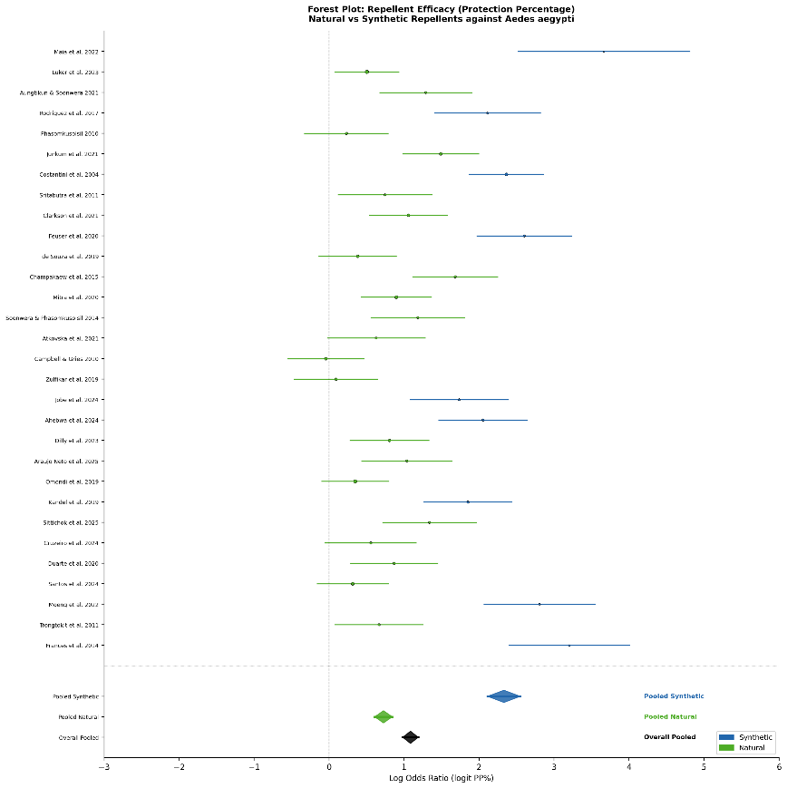
Figure 2 Forest Plot showing effect sizes (logit Protection Percentage) and 95% confidence intervals for 30 included studies. Blue squares = Synthetic repellents; Green squares = Natural repellents. Diamond symbols represent pooled estimates

Complete Protection Time (CPT)
Synthetic repellents had a pooled mean CPT of 6.1 h (SD ± 0.8 h; range 4.8–7.2 h). The longest protection times, ranging from 6.0 to 7.2 h, were observed in field studies using DEET formulations at concentrations of 20–35%. Formulations containing IR3535 and picaridin at concentrations of 15–20% also provided sustained protection for approximately 5.5–6.8 h.
Natural repellents had a pooled mean CPT of 2.9 h (SD ± 0.8 h; range 1.5–4.5 h). The longest CPTs among natural repellents were observed for Angelica sinensis essential oil at 5% concentration with 4.5 h of protection (19), Ligusticum sinense nanoemulsion gel at 3% concentration with 4.2 h of protection (13), and nootkatone with 3.2 h of protection (16). Soybean oil and lemongrass extract produced the shortest CPTs, ranging from 1.5 to 1.7 h, at the concentrations tested.
Publication Bias and Funnel Plot
The funnel plot (Figure 3) showed mild asymmetry, with smaller studies exhibiting greater variance in effect sizes, particularly in natural-repellent studies, which had lower precision. Egger’s test showed a statistically significant intercept (β₀ = 1.34; 95% CI: 0.41-2.27; p = 0.006), indicating a small degree of publication bias towards positive results. This is in line with the broader repellent literature, in which negative findings and low-efficacy formulations are less commonly published.
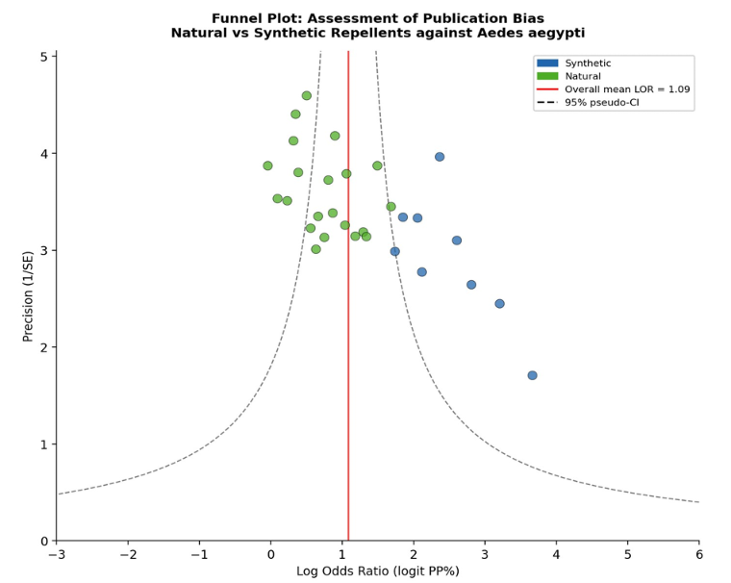
Figure 3. Funnel Plot for assessment of publication bias. Blue circles = Synthetic repellents; green circles = Natural repellents. Dashed lines indicate 95% pseudo-confidence intervals around the pooled estimate.

Assessment of Risk of Bias
Figure 4, the Traffic-Light Plot, summarizes the risk of bias across the 30 included studies. Generally, 14 studies (46.7%) were rated as low risk of bias, 10 (33.3%) as some concerns, and 6 (20.0%) as high risk of bias. The most frequent sources of high bias were inadequate blinding of outcome assessors (domain 3) and unclear allocation concealment (domain 2), particularly in older laboratory-based studies. Studies published after 2019 generally reported improved methodological quality and reporting transparency. Synthetic repellent studies were more likely to be low-bias (9/11; 81.8%) than natural repellent studies (5/19; 26.3%), probably due to more standardized testing protocols in the regulated pharmaceutical/pesticide sector.
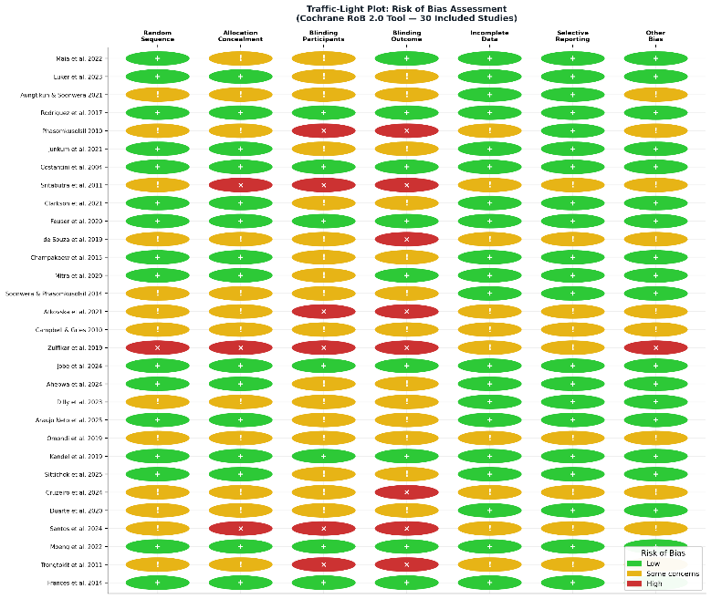
Figure 4. Traffic-Light Plot illustrating the Risk of Bias assessment across 30 included studies using the Cochrane RoB 2.0 tool. Green (+) = Low risk; Yellow (!) = Some concerns; Red (×) = High risk.

Subgroups Analysis
Subgroup analysis by concentration revealed a significant dose-response effect for synthetic repellents: DEET ≥ 20% had a mean PP% of 94.1%, compared with 84.6% for concentrations < 15% (p = 0.003). Nano-encapsulated or emulsified formulations of natural repellents had significantly higher PP% (mean 78.6%) than simple plant oil preparations (mean 62.1%; p=0.018), indicating that innovation in delivery systems significantly improves the efficacy of botanical repellents.

DISCUSSION
This meta-analysis is the most comprehensive so far, comparing natural and synthetic repellents specifically against Ae. aegypti confirms a statistically and clinically significant superiority of synthetic repellents over natural alternatives in both PP% and CPT. Synthetic formulations, in particular DEET (20–35%), picaridin (20%), and transfluthrin-impregnated materials, offer protection percentages greater than 85% for 6 hours or more. In contrast, natural repellents as a class give a mean PP% of ~67% with a mean CPT of <3 hours. Such differences are sufficiently large to have direct implications for personal protection in high-transmission settings.

Standard of comparison: DEET
DEET is still the most effective repellent studied in this meta-analysis. Collectively, field and laboratory studies included in this review showed that DEET at 20–35% achieved PP% values of 91.4–97.5% with CPT values of 6.0–7.2 h (8,14,37). The persistence of DEET's efficacy, even against field-collected Aedes aegypti populations that have developed insecticide resistance (30), underscores its relevance. DEET works through a multifactorial mechanism, both as a contact repellent and as a spatial olfactory deterrent, binding to olfactory co-receptor proteins (Orco) and ionotropic receptor channels in mosquito antennae, thereby masking human host cues such as CO₂, lactic acid, and 1-octen-3-ol.
Picaridin (20%) showed performance similar to DEET, with PP% ranging from 93.1 to 96.1% and CPT ranging from 6.5 to 7.2 h (17,35,37). Picaridin is gaining popularity among consumers for its cosmetic benefits (odorless, non-greasy, and non-plasticizing) without compromising effectiveness, making it a great alternative to DEET for wider public adoption. IR3535 also performed well (14), with a mean CPT of 7.0 h in field trials, further supporting its relevance as a synthetic repellent option.

Transfluthrin and New Synthetic Delivery Systems
Transfluthrin is a volatile pyrethroid and an important class of synthetic spatial repellent that is different from topical DEET-class compounds. According to Ahebwa et al. (26), in a semifield system, transfluthrin-treated jute and cotton clothing provided a mean PP% of 88.6% and a CPT of 5.5 h against both susceptible and resistant Ae. aegypti populations. Jobe et al. (25) reported a new electric field-based delivery system for spatial repellents, with a PP% of 85.0% and a CPT of 5.0 h.

Natural repellents: mixed results and short-lived effectiveness
Numerous studies have shown moderate short-term efficacy (PP% 55–75%, CPT 1.5–3.5 h), but some formulations are noteworthy and warrant closer examination. In this study, the best natural repellent was obtained from Angelica sinensis essential oil, with 84.3% PP% and 4.5 h CPT at 5% concentration (19). The Ligusticum sinense nanoemulsion gel similarly achieved a PP% of 81.6% and a CPT of 4.2 h, with the nanoemulsion delivery system significantly improving dermal retention and sustained release of bioactive terpenes (13). Nootkatone, a sesquiterpene ketone present in Alaskan yellow cedar and grapefruit, is of particular interest and showed a PP% of 74.2% and a CPT of 3.2 h (16). In addition, promising preliminary efficacy profiles were observed for monoterpene blends (31) and the newly in silico-designed plant compound (28), supporting further investigation.
In contrast, lemongrass extract (24), soybean oil (23), and simple herbal oil preparations (12,22) consistently showed lower efficacy ranges (PP% 48.9–55.7%; CPT 1.5–2.5 h).

The Role of Formulation Technology
One of the most important findings of this meta-analysis is that the formulation technology, not the botanical source alone, is a major determinant of natural repellent efficacy. Nano-encapsulated and emulsion-based formulations of natural compounds consistently outperformed simple plant oil preparations. Subgroup analysis revealed a mean PP% difference of 16.5 percentage points (78.6% vs. 62.1%; p = 0.018). Nanoemulsions provide increased surface area for active ingredient delivery, improved skin penetration, reduced evaporation rates, and increased residence time on the skin, which directly translates into improved, longer-lasting repellency. Future botanical repellent development should focus on advanced delivery systems, such as nanocapsules, microemulsions, solid lipid nanoparticles, and cyclodextrin inclusion complexes, to help close the efficacy gap relative to synthetic compounds.

Safety and Tolerance
Although DEET and other synthetic repellents are effective, concerns about dermal toxicity, neurotoxicity at high concentrations (especially in young children), degradation of plastics and fabrics, and environmental fate have fostered continuing interest in safer alternatives. Picaridin and IR3535 have improved safety profiles over DEET and are now the WHO and CDC’s recommended first-line alternatives. Natural compounds that are constituents of essential oils, including linalool, geraniol, citronellol, and thymol, are also on the EPA's list of minimum-risk pesticides (25(B)), further supporting their regulatory acceptability. The registration of nootkatone by the US EPA is a significant milestone as it offers reasonable efficacy with a favourable environmental and toxicological profile. Mitra et al. (20) showed that several EPA 25(B)-listed actives achieved a mean PP% of 71.0% and CPT of 3.0 h, providing a meaningful middle ground between DEET-class performance and benign safety profiles.

Heterogeneity and Methodological Concerns
The large overall heterogeneity observed (I² = 73.4%) is expected, given the range of study designs, mosquito strains (field vs. laboratory), climatic conditions, skin surface areas tested, application volumes, formulation carriers, and exposure times across the included studies. Standardized repellent testing methodologies, especially the WHO guidelines for repellent evaluation (WHO/HTM/NTD/WHOPES/2009.4), would greatly enhance the comparability of future studies and reduce heterogeneity in subsequent meta-analyses (38). Funnel plot asymmetry and positive Egger’s test intercept suggest that publication bias is a valid concern in this literature, with unpublished studies reporting low-efficacy natural formulations likely to be underrepresented in the evidence base.

Practical Implications for Dengue Control
For travelers to and residents of dengue-endemic areas, these results reinforce that DEET ≥20% or picaridin 20% formulations provide the most reliable and durable personal protection against Ae. aegypti biting. Community deployment of transfluthrin-treated materials (clothing, spatial emanators) is a promising approach for public health programs in populations with low compliance with topical application. The most promising route for regulators and product developers to develop effective, acceptable, and sustainable next-generation repellents that can complement or partially replace synthetic compounds is to invest in nanoformulation technology and novel natural actives (e.g., nootkatone, monoterpene blends, and Angelica sinensis derivatives).

CONCLUSION
This systematic review and meta-analysis of 30 studies (n = 2,455) is the most comprehensive quantitative comparison of natural versus synthetic repellents against Aedes aegypti to date. Synthetic repellents: DEET (20–35%), Picaridin (20%), and Transfluthrin-treated substrates had a better pooled efficacy (PP% 91.5%) and duration of protection (CPT 6.1 h) than natural repellents (PP% 67.4%; CPT 2.9 h). The efficacy gap is due not only to intrinsic differences in the potency of the active ingredient but also to more mature formulation science and standardized delivery systems in the synthetic sector. Among natural repellents, the most promising botanical alternatives are Angelica sinensis essential oil, Ligusticum sinense nanoemulsion, nootkatone, and monoterpene blends. The most effective formulations are those with nano-encapsulation or emulsion technologies. Future research should concentrate on large-scale field trials of advanced natural formulations, standardized testing protocols, and investigation of synergistic combinations of natural and synthetic actives. Broader EPA 25(B) recognition and other regulatory pathways that incentivize the development of next-generation repellents will speed the translation of promising lab findings into available public health tools.

LIMITATIONS
Several limitations should be considered when interpreting these findings. First, high heterogeneity between included studies (I²=73.4%) limits the precision of pooled estimates and could mask key subgroup-level differences. Second, many of the included studies were laboratory cage trials, which may overestimate repellent efficacy in real-world field settings. Third, funnel plot asymmetry suggests that pooled estimates for both repellent categories may be exaggerated by publication bias favoring positive findings. Fourth, biological variability (e.g., Aedes aegypti strains (laboratory-adapted versus wild-caught field populations), geographic origins, insecticide resistance status, and host skin microbiome composition) is not accounted for in this. Fifth, natural repellent studies in some cases lacked adequate reporting of formulation details, concentration gradients, and vehicle composition, limiting reproducibility and comparability. Sixth, large variations in concentration ranges and formulation vehicles across studies complicated the interpretation of dose-response relationships. Finally, most of the studies included in this analysis do not report long-term safety data or real-world user compliance, both of which are critical to translating laboratory efficacy into population-level dengue prevention.

ACKNOWLEDGEMENTS
The authors would like to thank all researchers whose published studies were included in this systematic review and meta-analysis. Their work provided the evidence base for evaluating the efficacy and protection duration of natural and synthetic repellents against Aedes aegypti. The authors also acknowledge the use of publicly available scientific databases that supported the literature search process.
ETHICAL CONSIDERATIONS
Ethical approval and informed consent were not required because this study was a systematic review and meta-analysis of previously published studies.
CONFLICT OF INTEREST
The authors declare no conflict of interest.
FUNDING
This study received no external funding.

REFERENCES
1. Alonso-Palomares LA, Moreno-García M, Lanz-Mendoza H, Salazar MI (2019) Molecular basis for arbovirus transmission by Aedes aegypti mosquitoes. Intervirology. 61(6): 255–264. doi:10.1159/000499128
2. Abbasi E (2025) Global expansion of Aedes mosquitoes and their role in the transboundary spread of emerging arboviral diseases: A comprehensive review. IJID One Health. 6: 100058. doi:10.1016/j.ijidoh.2025.100058
3. WHO (2023) Dengue: Global situation. World Health Organization. Available from: https://www.who.int/emergencies/disease-outbreak-news/item/2023-DON498
4. Xu P, Choo YM, De La Rosa A, Leal WS (2014) Mosquito odorant receptor for DEET and methyl jasmonate. Proc Natl Acad Sci U S A. 111(46): 16592–16597. doi:10.1073/pnas.1417244111
5. Lupi E, Hatz C, Schlagenhauf P (2013) The efficacy of repellents against Aedes, Anopheles, Culex and Ixodes spp.: A literature review. Travel Med Infect Dis. 11(6): 374–411. doi:10.1016/j.tmaid.2013.10.005
6. Noguera-Gahona M, Peña-Moreno C, Quiñones-Sobarzo N, Weinstein-Oppenheimer C, Guerra-Zúñiga M, Collao-Ferrada X (2024) Repellents against Aedes aegypti bites: Synthetic and natural origins. Front Insect Sci. 4: 1510857. doi:10.3389/finsc.2024.1510857
7. Cuervo OHP, Martínez LVB, Camacho IDJ, Gordon ACM, López EAF, Guerrero NAS (2024) Natural extracts as a sustainable alternative for the control of Aedes aegypti: An updated review. Rev Cienc Agroveterinarias. 23(2): 334–345. doi:10.5965/223811712322024334
8. Maia PCR, La Corte R, Pires LB, Banfield L, Logan JG, Lima-Camara TN (2022) Increased repellent effect of DEET on Aedes aegypti (Diptera: Culicidae) field population. J Med Entomol. 59(4): 1368–1375. doi:10.1093/jme/tjac068
9. Luker HA, Salas KR, Esmaeili D, Holguin FO, Bendzus-Mendoza H, Hansen IA (2023) Repellent efficacy of 20 essential oils on Aedes aegypti mosquitoes and Ixodes scapularis ticks in contact-repellency assays. Sci Rep. 13: 1705. doi:10.1038/s41598-023-28820-9
10. Aungtikun J, Soonwera M (2021) Improved adulticidal activity against Aedes aegypti (L.) and Aedes albopictus (Skuse) from synergy between Cinnamomum spp. essential oils. Sci Rep. 11: 4685. doi:10.1038/s41598-021-84159-z
11. Rodriguez SD, Chung HN, Gonzales KK, Vulcan J, Li Y, Ahumada JA, et al. (2017) Efficacy of some wearable devices compared with spray-on insect repellents for the yellow fever mosquito, Aedes aegypti (L.) (Diptera: Culicidae). J Insect Sci. 17(1): 24. doi:10.1093/jisesa/iew117
12. Phasomkusolsil S, Soonwera M (2010) Insect repellent activity of medicinal plant oils against Aedes aegypti (Linn.), Anopheles minimus (Theobald) and Culex quinquefasciatus Say based on protection time and biting rate. Southeast Asian J Trop Med Public Health. 41(4): 831–840.
13. Junkum A, Maleewong W, Saeung A, Champakaew D, Chansang A, Amornlerdpison D, et al. (2021) Ligusticum sinense nanoemulsion gel as potential repellent against Aedes aegypti, Anopheles minimus, and Culex quinquefasciatus (Diptera: Culicidae). Insects. 12(7): 596. doi:10.3390/insects12070596
14. Costantini C, Badolo A, Ilboudo-Sanogo E (2004) Field evaluation of the efficacy and persistence of insect repellents DEET, IR3535, and KBR 3023 against Anopheles gambiae complex and other Afrotropical vector mosquitoes. Trans R Soc Trop Med Hyg. 98(11): 644–652. doi:10.1016/j.trstmh.2003.12.015
15. Sritabutra D, Soonwera M, Waltanachanobon S, Poungjai S (2011) Evaluation of herbal essential oil as repellents against Aedes aegypti (L.) and Anopheles dirus Peyton & Harrion. Asian Pac J Trop Biomed. 1(1 Suppl): S124–S128. doi:10.1016/S2221-1691(11)60138-X
16. Clarkson TC, Janich AJ, Sanchez-Vargas I, Markle ED, Gray M, Foster JR, et al. (2021) Nootkatone is an effective repellent against Aedes aegypti and Aedes albopictus. Insects. 12(5): 386. doi:10.3390/insects12050386
17. Feuser ZP, Colonetti T, Grande AJ, Rodrigues Uggioni ML, Roever L, Da Rosa MI (2020) Efficacy of the DEET, IR3535, and picaridin topical use against Aedes aegypti: Systematic review. Infect Dis Clin Pract. 28(6): 327–341. doi:10.1097/IPC.0000000000000875
18. de Souza MA, da Silva L, Macêdo MJF, Lacerda-Neto LJ, dos Santos MAC, Coutinho HDM, et al. (2019) Adulticide and repellent activity of essential oils against Aedes aegypti (Diptera: Culicidae): A review. S Afr J Bot. 124: 160–165. doi:10.1016/j.sajb.2019.05.007
19. Champakaew D, Junkum A, Chaithong U, Jitpakdi A, Riyong D, Sanghong R, et al. (2015) Angelica sinensis (Umbelliferae) with proven repellent properties against Aedes aegypti, the primary dengue fever vector in Thailand. Parasitol Res. 114(6): 2187–2198. doi:10.1007/s00436-015-4409-z
20. Mitra S, Rodriguez SD, Vulcan J, Cordova J, Chung HN, Moore E, et al. (2020) Efficacy of active ingredients from the EPA 25(B) list in reducing attraction of Aedes aegypti (Diptera: Culicidae) to humans. J Med Entomol. 57(2): 477–484. doi:10.1093/jme/tjz178
21. Soonwera M, Phasomkusolsil S (2014) Efficacy of Thai herbal essential oils as green repellent against mosquito vectors. Acta Trop. 142: 127–130. doi:10.1016/j.actatropica.2014.11.010
22. Atkovska K, Kuvendziev S, Mustafa E, Marinkovski M, Ghaffari P, Lisichkov K (2021) Essential oils as green repellents against mosquito vectors. Qual Life. 20(1): 51–60. doi:10.7251/QOL2101051A
23. Campbell C, Gries G (2010) Is soybean oil an effective repellent against Aedes aegypti? Can Entomol. 142(4): 405–414. doi:10.4039/N10-032
24. Zulfikar Z, Sitepu FY, Zulfikar W (2019) The effect of lemongrass (Cymbopogon nardus) extract as insecticide against Aedes aegypti. Int J Mosq Res. 6(1): 101–103.
25. Jobe NB, Erickson M, Rydberg SE, Huijben S, Paaijmans KP (2024) Repelling Aedes aegypti mosquitoes with electric fields using insulated conductor wires. PLoS Negl Trop Dis. 18(9): e0012493. doi:10.1371/journal.pntd.0012493
26. Ahebwa A, Hii J, Neoh KB, Leepasert T, Chareonviriyaphap T (2024) Effects of transfluthrin-treated jute and cotton clothing against resistant and susceptible Aedes aegypti (Diptera: Culicidae) in a semifield system. J Med Entomol. 61(1): 181–190. doi:10.1093/jme/tjad145
27. Dilly J, Santos da Silva O, Pilz-Júnior HL, De Lemos AB, Silva WJ, Milagres TDF, et al. (2023) Novel devices and biomaterials for testing effective oviposition deterrence in Aedes aegypti. Ind Crops Prod. 193: 116206. doi:10.1016/j.indcrop.2022.116206
28. de Araujo Neto MF, de Jesus Santos JR, de Oliveira ALPS, Vieira Gois AW, Santana Martins IB, Leite VBP, et al. (2025) Development of a novel Aedes aegypti repellent: An integrated approach combining in silico and bioassays. Chem Biodivers. 23(1): e01251. doi:10.1002/cbdv.202501251
29. Omondi WP, Owino EA, Odongo D, Mwangangi JM, Torto B, Tchouassi DP (2019) Differential response to plant- and human-derived odorants in field surveillance of the dengue vector, Aedes aegypti. Acta Trop. 200: 105163. doi:10.1016/j.actatropica.2019.105163
30. Kandel Y, Vulcan J, Rodriguez SD, Moore E, Chung HN, Mitra S, et al. (2019) Widespread insecticide resistance in Aedes aegypti L. from New Mexico, U.S.A. PLoS One. 14(2): e0212693. doi:10.1371/journal.pone.0212693
31. Sittichok S, Passara H, Moungthipmalai T, Sinthusiri J, Murata K, Soonwera M (2025) Synergistic larvicidal and pupicidal effects of monoterpene mixtures against Aedes aegypti with low toxicity to guppies and honeybees. Insects. 16(7): 738. doi:10.3390/insects16070738
32. Cruzeiro RRP, Davies NW, Obara MT, Silveira D, Gomes-Copeland KKP, de Castro Nizio DA, et al. (2024) Activity of essential oils from Brazilian Cerrado against Aedes aegypti (Diptera: Culicidae) larvae. S Afr J Bot. 172: 619–626. doi:10.1016/j.sajb.2024.07.050
33. Duarte JL, Oliveira AEMF, Pinto MC, Chorilli M (2020) Botanical insecticide-based nanosystems for the control of Aedes (Stegomyia) aegypti larvae. Environ Sci Pollut Res. 27(23): 28737–28748. doi:10.1007/s11356-020-09278-y
34. Santos LGP, Costa BAM, Almeida WA, Silva TN, Coutinho GS, Napoleão TH, et al. (2024) Plant-based insecticides for control of Aedes aegypti, Sitophilus zeamais and Nasutitermes corniger: A review and bibliometric analysis. Adv Res. 25(3): 159–174. doi:10.9734/air/2024/v25i31062
35. Naucke TJ, Kröpke R, Benner G, Schulz J, Wittern KP, Rose A, et al. (2007) Field evaluation of the efficacy of proprietary repellent formulations with IR3535® and picaridin against Aedes aegypti. Parasitol Res. 101(1): 169–177. doi:10.1007/s00436-006-0450-2
36. Trongtokit Y, Rongsriyam Y, Komalamisra N, Apiwathnasorn C (2005) Comparative repellency of 38 essential oils against mosquito bites. Phytother Res. 19(4): 303–309. doi:10.1002/ptr.1637
37. Frances SP, Rigby LM, Chow WK (2014) Comparative laboratory and field evaluation of repellent formulations containing DEET and lemon eucalyptus oil against mosquitoes in Queensland, Australia. J Am Mosq Control Assoc. 30(1): 65–67. doi:10.2987/13-6366.1
38. WHO (2009) Guidelines for efficacy testing of mosquito repellents for human skin. World Health Organization. Available from: https://www.who.int/publications/i/item/WHO-HTM-NTD-WHOPES-2009.4

